**TEA MANAGEMENT SYSTEM**

**(A Case Study of** **Kasuku Tea Packers Limited)**

|  |
| --- |
|  |

**JANUARY 2023**

**IT SYSTEM PROPOSAL SUBMITTED TO THE DEPARTMENT OF INFORMATION TECHNOLOGY IN THE SCHOOL OF COMPUTING AND INFORMATION TECHNOLOGY IN PARTIAL FULLFILMENT OF THE REQUIREMENTS FOR THE AWARD OF THE DIPLOMA IN INFORMATION TECHNOLOGY OF JOMO KENYATTA UNIVERSITY OF AGRICULTURE AND TECHNOLOGY.**

**ABDALLAH AHMED ABDALLAH**

**DECLARATION**

This project proposal is my original work and has not been presented for a diploma or degree award in any other university.

Signature ……………………………… Date……………………………….

**SCT121-C005-0037/2021**

**ABDALLAH AHMED ABDALLAH**

This project proposal has been submitted for examination with my approval as the student’s university supervisor.

Signature……………………………….. Date……………………………

**MR. WALTER KIHUYA**

# DEDICATION

I dedicate this proposal to the Almighty God and to my family and friends who were of great help of developing the proposal.

# acknowledgement

I would like to acknowledge my parents and my friends for their support continuous encouragement throughout the project proposal. I also would like to acknowledge my supervisor Walter Kihuya for his support and guidance throughout this work.

# DEFINITIONS OF TERMS

**User friendly** Interface that conforms to the principles of Human Computer Interaction

**Usability** Performs all its tasks easily by users with little to no training needed.

# acronyms

**IT** Information Technology

**SQL** Structured Query Language

**MySQL** Structured Query Language Improved

**JKUAT** Jomo Kenyatta University of Agriculture and Technology

**MSA** Mombasa

**CBD** Central Business District

**SDD** Software Design Document

**TABLE OF CONTENTS**

DECLARATION Error! Bookmark not defined.

DEDICATION ii

ACKNOWLEDGEMENT iii

DEFINITIONS OF TERMS iv

ACRONYMS v

LIST OF TABLES ix

LIST OF FIGURES x

LIST OF APPENDICES xi

ABSTRACT xii

CHAPTER ONE: INTRODUCTION 1

1.0 INTRODUCTION 1

1.1 PROBLEM DESCRIPTION 1

1.1.1 BACKGROUND OF THE STUDY 1

1.1.2 PROBLEM STATEMENT 2

1.2 PROJECT OBJECTIVE 3

1.2.1 GENERAL OBJECTIVE 3

1.2.2 SPECIFIC OBJECTIVE 3

1.2.3 RESEARCH QUESTIONS 3

1.3 PROJECT SCOPE 3

1.3.1 SCOPE 3

1.3.2 TARGET USER 3

1.3.3 SPECIFIC PLATFORM 4

1.4 CONSTRAINTS 4

1.5 SIGNIFICANCE OF THE PROJECT 4

1.6 SUMMARY 4

CHAPTER TWO: LITERATURE REVIEW 5

2.0 INTRODUCTION 5

2.1 SYSTEM REVIEW 6

2.1.1 EXISTING PRODUCTS 6

2.1.2 ADVANTAGES 9

2.1.3 DISADVANTAGES 9

2.2 SYSTEM ADAPTATIONS 9

CHAPTER THREE: RESEARCH METHODOLOGY 10

3.0 INTRODUCTION 10

3.1 DEVELOMENT APPROACH 10

3.1.1 STAGES OF RAPID APPLICATION DEVELOPMENT MODEL 10

3.2 REQUIREMENT SPECIFICATION 11

3.3 FACT FINDING TECHNIQUES 12

3.3.1 QUESTIONNAIRES 12

3.3.2 OBSERVATION 13

3.3.3 INTERVIEWS 13

3.4 LOGICAL DESIGN 14

A) USE CASE DIAGRAM 14

B) ACTIVITY DIAGRAM 15

C) CLASS DIAGRAM 16

D) ENTITY RELATIONSHIP DIAGRAM 17

E) DATA FLOW DIAGRAM 18

3.5 DATABASE DESIGN 19

APPENDICES 21

APPENDIX I: QUESTIONNAIRE 21

APPENDIX II: PROJECT SCHEDULE 22

APPENDIX III: BUDGET 23

REFERENCES 24

# LIST OF TABLES

Table 3.1: User Table 19

Table 3.2: Farmers Table 19

Table 3.3: Tea collection Table 20

Table 3.4: Payment Table 20

Table 3.5: Rates Table 20

# LIST OF FIGURES

Figure 2.1: James Finlay Limited 6

Figure 2.2: Kaisugu Limited 7

Figure 2 3: Kericho Gold. 8

Figure 3.1: RAD methodology 10

Figure 3.2: Use Case Diagram 14

Figure 3.3: Activity Diagram 15

Figure 3.4: Class Diagram 16

Figure 3. 5: Entity Relationship Diagram 17

Figure 3.6: Level 0 Data Flow Diagram 18

# LIST OF APPENDICES

APPENDIXI: QUESTIONNAIRE ……………………………………………………………...21

APPENDIX II: PROJECT SCHEDULE …………………………………………………….….22

APPENDIX III: BUDGET ……………………………………………………………………...23

# abstract

This project is about a tea management system. Tea management and processing is one of the growing professions in the country currently. There are many tea processing companies coming up in the country and hence need for an adequate reliable system to manage the tea and keep records secure and available for easier and faster retrieval of information. The system allows the admin to register new farmers, record collection of tea and issue a receipt to the farmer for the relevant collection, pay the farmers for the relevant quantity of tea collected and finally generate tea payment reports and individual farmer reports.This system will be developed using Java Programming Language, NetBeans 8.1 as the IDE and database using SQL. The Tea Management System will be advantageous as it will provide a user-friendly environment and it will also increase security and minimizes human calculation errors.

# Chapter one: introduction

## Introduction

Tea management is an import industry in the country currently. Most of the factories have not been fully automated and hence the need of a software system to assist in proper management. This management system is fully automated to assist both factories and farmers and ensure accurate and proper outcomes and feedback.

## 1.1 PROBLEM DESCRIPTION

## 1.1.1 Background of the study

Tea is mainly grown in several districts which include Kericho, Bomet, Nandi, Kiambu, Thika, Maragua, Muranga, Sotik, Kisii, Nyamira, Nyambene, Meru, Nyeri, Kerinyaga, Embu, Kakamega, Nakuru and Trans-nzoia. In these areas the crop enjoys 80% favorable weather patterns. As indicated earlier production is shared between multinational companies and small-scale growers. Both sectors have benefited from many scientific advances in tea cultivation, although the average yields in the smallscale sector are below those in the estates sector which stands at around 1800 kg ha-1. Despite the yield disparities, the small-scale sector has managed to achieve higher quality standards resulting in consistently higher auction prices. The industry is the largest employer in the private sector, with more than 80,000 people working on the estate and about 3 million people earning their livelihood from the sector(R.M. Gesimba, M.C. Langat, 2005)

**The Kenya Tea Development Agency (KTDA):** Kenya Tea Development Agency’s predecessor the Kenya Tea Development Authority, was established in 1964 by an act of parliament as a parastatal charged with the responsibility of developing and fostering the young and nascent small scale growers’ sector. From one initial factory serving 19,000 growers and only 4,700 ha of tea, today KTDA has 51 factories spread in 24 districts. The factories are owned by 380,000 growers who cultivate 92,800 ha of tea.

## 1.1.2 Problem Statement

The current state of affairs of Kasuku Tea Packers Ltd Tea Company involves many manual activities and operations. The farmer’s details in the collection center are filled on a form and payments are recorded in a book. Their back-up system is also outdated as they use the old filing system and redundancy of data occurs which can be avoided. Files also take up a lot of space leading to congestion. The company is willing to expand their horizons but it’s difficult since they have to decide how their files will be shared. There is therefore a need to develop a reliable and effective system to help in farmer’s registration in the tea companies, keep records of farmer’s details and manage auditing and paying of taxes.

The consequence of the state of affairs are numerous and creates a tremendous implication in the management of the tea company. These implications also extend to the customers as they have a difficulty feeling when it comes to the image of the company. The limitations of using manual operations include speed of data processing and retrieval of records is very slow and time consuming, in case of disaster (like fire or floods) data would be lost as there is no back-up, redundancy of data may occur when details are manually entered more than once, a lot of space is needed to cater for the volumes of receipt books hence congestion, security issues for example, files being easily accessed by employees from other sections/departments, prone to mistakes as the whole system is operated manually, auditing and tax payments would not easily match up, in case of theft of tea by a company worker, his or her details may not be known by the company because he or she may have misplaced the book records of the workers.

The system will ideally embrace the functionalities and operations of the system. The system will increase the ease of managing the company in terms of efficiency, ease and time as intended to be. The system will generally be capable of providing a means of performance analysis through objective reports that have vital tools and functions to aid in the tea operations. The system will also uniquely identify the different requirements contained in the database hence enhancing consistency. The system should perform functions such as manipulation of data, generating reports, maintaining accuracy by deleting and solving errors. The proposed system will be efficient in terms of eliminating errors and data redundancy.

## 1.2 PROJECT OBJECTIVE

## 1.2.1 GENERAL OBJECTIVE

To develop Tea Management System

## 1.2.2 SPECIFIC OBJECTIVE

1. To analyze the existing/current system for Tea management system
2. To design the proposed system for Tea management system
3. To develop the Tea management system
4. To test the final system using User Acceptability Test.

## 1.2.3 RESEARCH QUESTIONS

1. What are the techniques to be used for analysis of the manual system?
2. Which methods and methodologies will be used to develop the proposed system?
3. Which tools will be used in the development of the Tea management system?
4. What are the available test methods to be used to access the final system?

## 1.3 PROJECT SCOPE

## 1.3.1 SCOPE

The focus of this work will be during the early stages of the tea management as tea is being brought into the factory, the measurement and recording of the relevant data and the use of the data to calculate payments to farmers, generating receipts and reports that will be used to make decision for the company.

## 1.3.2 TARGET USER

The Tea Management System will focus specifically on the farmers who bring the tea leaves in the factory.

## 1.3.3 SPECIFIC PLATFORM

**HARDWARE REQUIREMENTS**

Intel dual Core processor or faster, minimum of 0.5 GB available space

**SOFTWARE REQUIREMENTS**

Windows OS 8 or above

MySQL

Jdk

## 1.4 CONSTRAINTS

The major limitations of this project were data collection difficulties as failed interviews due to language barriers and some of the questions in the questionnaire were left blank or incorrect answers submitted.

## 1.5 SIGNIFICANCE OF THE PROJECT

As opposed to the existing system, the proposed Tea Management System will provide the measurement and recording of the relevant data and the use of the data to calculate payments to farmers, generating receipts and reports

## 1.6 SUMMARY

This chapter has covered about the introduction of the proposal including the problem background, problem statement, objective and scope of the project. This proposal is done some literature reviews from some resources such as internet, books, conference and journals.

# chapter two: literature review

## INTRODUCTION

Literature review is the evaluation and analysis of the existing literature related to selected area of study. This chapter involved an assessment of the existing literature and systems for identification of the knowledge gap with a view of developing a better system, understand the current systems and their critiques and have a summary about the system developed and how the developed system would be better than the existing system.

Tea Camellia sinensis belongs to the family Theaceae (Camelliaceae). The genus Camellia developed in Asia centered around the Himalayan Mountains. However, the two types of Camellias with stimulant properties developed separately. Camellia sinensis Var. sinensis on the northern slopes of Himalayan while C. sinensis Var. assamica on the southern region and adjoining plains. The Cambodian type makes the third type of tea. Tea was first introduced in Kenya from India by a colonial settler G.W Caine in 1903. Currently tea is the leading export crop in Kenya. In the world market, Kenya is the third largest producer of black tea after India and Sri Lanka. In 2001, the tea industry turnover was US$ 474 million of which US$ 437 million occurred from export earnings with the balance being the value of locally sold tea. In the year 2002 Kenya was second only to Sri Lanka in exports of black tea (R.M. Gesimba, M.C. Langat, 2005).

The success story of tea is a product of three main developments. First the government policy after independence to integrate small scale growers into the mainstream of tea growing. Currently the small scale growers under the umbrella of Kenya Tea Development Agency (KTDA) account for sixty percent of the total tea production while the multinational sector and large scale growers account for the remaining forty percent. The establishment of an efficient estate sector under the British tea companies has also introduced revolutionary improvements in the estate and factory management with a resulting five-fold increase in output. The selection of high yielding varieties mainly by the Tea Research Foundation of Kenya (TRFK) and the selective application of herbicides and improved planting and cultivation methods, have had a dramatic effect on yield. In 1965, average yields in the estate sector were 948 kg ha–1. In 2002 they were two and a half times higher at 2498 kg ha-1[1] (R.M. Gesimba, M.C. Langat, 2005).

## 2.1 SYSTEM REVIEW

## 2.1.1 EXISTING PRODUCTS

**James Finlay Kenya Limited**

Is a web system for James Finlay Kenya Limited.

Finlays is leading independent B2B manufacturer and supplier of tea, coffee and botanical solutions to beverage brand owners worldwide.

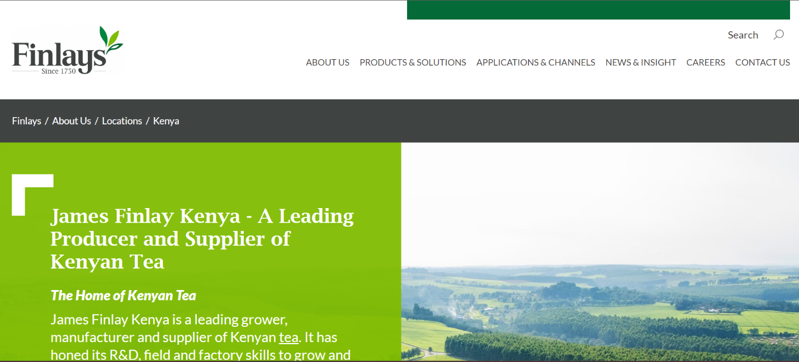

Figure 2.1: James Finlay Limited (Finlay, 2022)

**Kaisugu Limited**

Web system for Kaisugu Limited

Kaisugu is a a private company which supplies tea locally and internationally. The website shows the tea products the manufacture and supply.

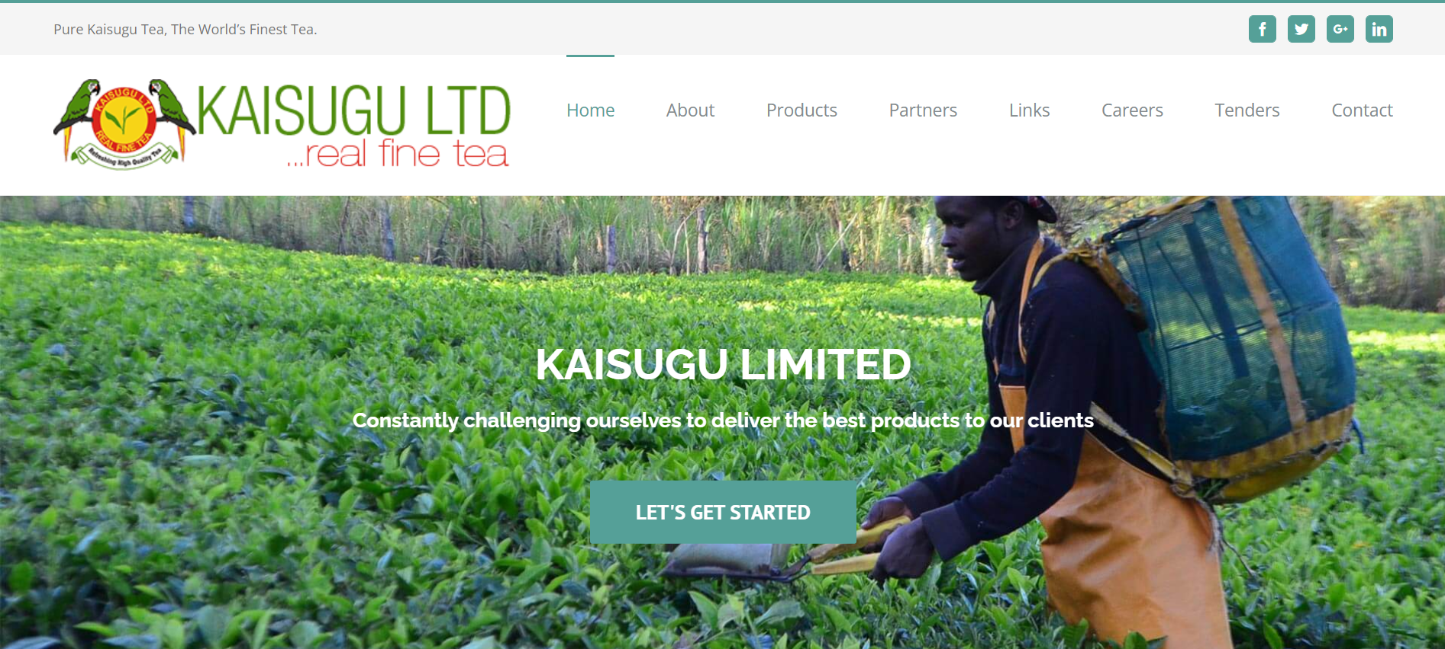

Figure 2.2: Kaisugu Limited (Kaisugu, 2022)

**Kericho Gold**

Web system for Kericho Gold.

Kericho Gold is a special blend of fine teas from some of the best tea estates in Kenya; carefully selected weekly by expert Tea Tasters for the richness of their taste, flavor and aroma to bring out the quality and ensure that high standards are maintained



Figure 2.3: Kericho Gold (Kericho,2023)

## 2.1.2 Advantages

**James Finlay Kenya Limited**

1. Good description about the company
2. Informational design

**Kaisugu Limited**

1. Well-designed Interface.
2. Most features are equipped

**Kericho Gold**

1. Easier to use even for novices
2. Clear details of the products available.

## 2.1.3 Disadvantages

**James Finlay Kenya Limited**

1. Often lags and loads for a long time.
2. Too much information on homepage.

**Kaisugu Limited**

1. Not much attractive for the user.
2. No online purchase of tea products.

**Kericho Gold**

1. A lot of information is compressed at the same place.
2. Advertisement pop ups.

## 2.2 SYSTEM ADAPTATIONS

The proposed Tea management system will be simple, user-friendly graphical user interface and will enable the measurement and recording of the relevant data and the use of the data to calculate payments to farmers, generating receipts and reports that will be used to make decision for the company

# chapter three: research methodology

## INTRODUCTION

In software engineering and project management, a methodology is a codified set of practices (sometimes accompanied by training materials, formal educational Programs, worksheets, and diagramming tools) that may be reputably carried out to produce software.

## 3.1 DEVELOMENT APPROACH

In general, Rapid Application Development (RAD) approaches to software development put less emphasis on planning and more emphasis on an adaptive process. Prototypes are often used in addition to or sometimes even instead of design specifications.

## 3.1.1 STAGES OF RAPID APPLICATION DEVELOPMENT MODEL

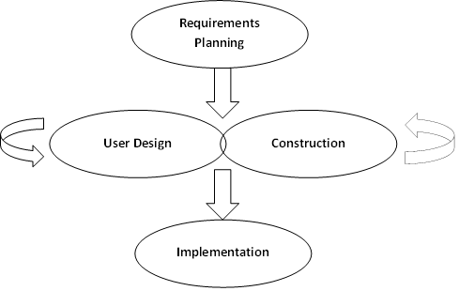

Figure3.1: RAD methodology (WaveMaker, 2021)

**Phase 1: Requirements planning**

**This phase is equivalent to a project scoping meeting. Although the planning phase is condensed compared to other project management methodologies, this is a critical step for the ultimate success of the project. During this stage, developers, clients (software users), and team members communicate to determine the goals and expectations for the project as well as current and potential issues that would need to be addressed during the build.**

**Phase 2: User design**

**Once the project is scoped out, it’s time to jump right into development, building out the user design through various prototype iterations.**

**Implementation and unit testing**

During this phase, design is implemented. If the Software Design Document (SDD) is complete, the implementation or coding phase proceeds smoothly, because all the information needed by software developers is contained in the SDD. During testing, the code is thoroughly examined and modified. Small modules are tested in isolation initially.

**Phase 3: Rapid construction**

**Phase 3 takes the prototypes and beta systems from the design phase and converts them into the working model. Because the majority of the problems and changes were addressed during the thorough iterative design phase, developers can construct the final working model more quickly than they could by following a traditional project management approach.**

**Phase 4: Implementation**

**This is the implementation phase where the finished product goes to launch. It includes data conversion, testing, and changeover to the new system, as well as user training. All final changes are made while the coders and clients continue to look for bugs in the system.**

## 3.2 REQUIREMENT SPECIFICATION

**3.2.1 Functional Requirement**

The functional requirement’s part discusses the functionalities required from the system. The system is considered to perform a set of high-level functions. They include:

1. To allow the system administrator to add a new farmer detail.
2. To allow the system administrator to add payment for the farmers and generate reports.

**3.2.2 Non-Functional Requirement**

Nonfunctional requirements deal with the characteristics of the system which cannot be expressed as functions - such as the maintainability of the system, portability of the system, usability of the system. The following will be the non-functional requirement:

1. Reliability: the system has ensured trustworthy and perform consistently well by maintaining security and integrity during operations.
2. Usability: the system is able to perform all its tasks and have a user-friendly interface that will be easy to use and manage without requiring training of the system users.
3. Security: each user is having a different set of access support with three security rules of confidentiality, integrity and availability.

## 3.3 FACT FINDING TECHNIQUES

The data collection methods that were used to collect information in the context of the project were as follows:

## 3.3.1 Questionnaires

A questionnaire is a method to collect data from the target users in a specific knowledge domain. According to (Beaney, 2012), questionnaire is a well-known technique to collect demographic data and users’ opinions. The design of a questionnaire is important because it addresses the research. This is a very commonly used method of collecting primary data. Here information is collected through a set of questionnaires. A questionnaire is a document prepared by the investigator containing a set of questions. These questions relate to the problem of enquiry directly or indirectly. Here first the questionnaires are mailed or hand-delivered to the informants with a formal request to answer the question and send them back. For better response the investigator should bear the postal charges. The questionnaire should carry a polite note explaining the aims and objective of the enquiry, definition of various terms and concepts used there.

## 3.3.2 Observation

Observation method will be used in the analysis and investigation of the current system it was used simply because it proved to be the cheapest in terms of collecting data compared to other methods.

## 3.3.3 Interviews

This method will be used to gather information from those who work with the manual Tea Operations where traditionally a farmer would go to the company to get registered manually. The tea workers said that the old system actually did not bring a lot of customers. But with the explanation of the new system, they actually agreed that it would be good. Interviews provide immediate response and helped the project designer to acquire accurate and first-hand information from the interviewees who were very much aware about the operation of the existing system, which was under investigation.

## 3.4 LOGICAL DESIGN

## A) USE CASE DIAGRAM

`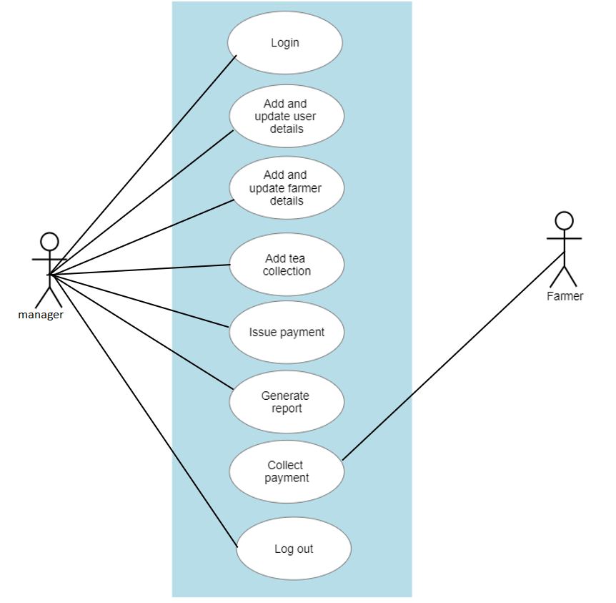

Figure 3.2: Use Case Diagram

## B) ACTIVITY DIAGRAM

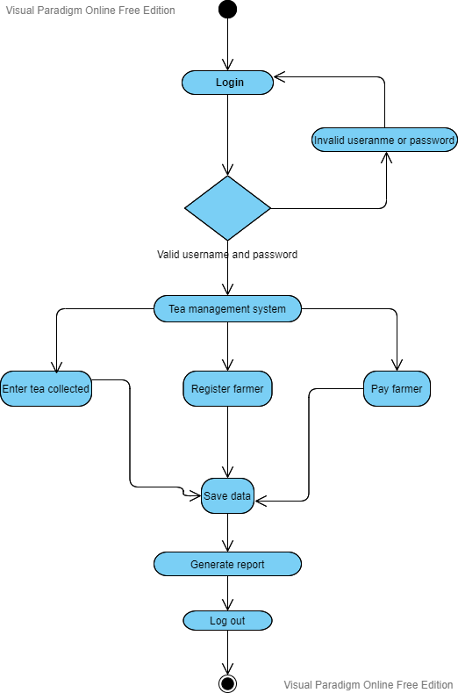



Figure 3.3: Activity Diagram.

## C) CLASS DIAGRAM

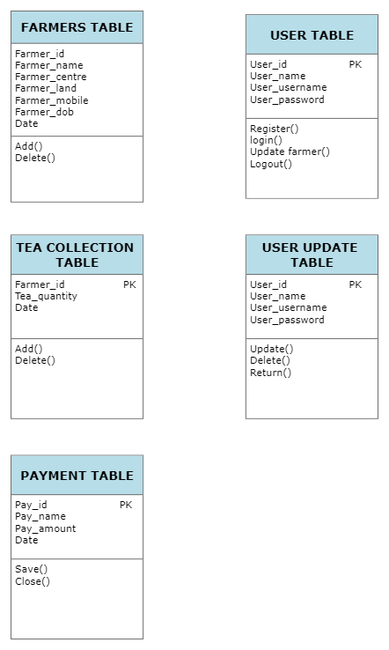

Figure 3.4: Class Diagram

## D) ENTITY RELATIONSHIP DIAGRAM

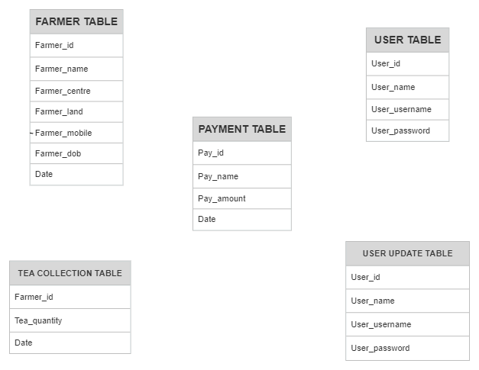

Figure 3.5: Entity Relationship Diagram

## E) DATA FLOW DIAGRAM

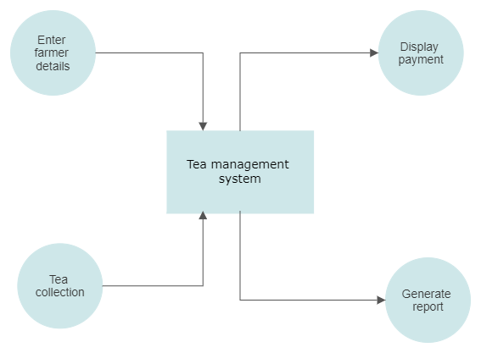

Figure 3.6: Level 0 Data Flow Diagram

## 3.5 DATABASE DESIGN

**DATABASE SCHEMA**

Table 3.1: User Table

|  |  |  |  |
| --- | --- | --- | --- |
| **Field** | **Data Type** | **Null** | **Constraints** |
| User_id | Int (10) | No | Primary Key |
| User_name | Varchar(20) | No |  |
| User_username | Varchar(20) | No |  |
| User_password | Varchar(20) | No |  |

Table 3.2: Farmer Table

|  |  |  |  |
| --- | --- | --- | --- |
| **Field** | **Data Type** | **Null** | **Constraints** |
| Farmer_id | Int(10) | No | Primary Key |
| Farmer_name | Varchar(20) | No |  |
| Collection_centre | Varchar(50) | No |  |
| Size_land | Varchar(20) | No |  |
| Farmer_dob | Int(10) | No |  |
| Farmer_mobile | Int(10) | No |  |

Table 3.3: Tea collection Table

|  |  |  |  |
| --- | --- | --- | --- |
| **Field** | **Data Type** | **Null** | **Constraints** |
| Farmer_id | Int (10) | No | Primary Key |
| Tea_quantity | Int (5) | No |  |
| Date | Date | No |  |

Table 3.4: Payment Table

|  |  |  |  |
| --- | --- | --- | --- |
| **Field** | **Data Type** | **Null** | **Constraints** |
| Pay_id | Int (10) | No | Primary Key |
| Pay_name | Varchar(30) | No |  |
| Pay_date | Date | No |  |
| Pay_amount | Int (10) | No |  |

Table 3.5: Rates Table

|  |  |  |  |
| --- | --- | --- | --- |
| **Field** | **Data Type** | **Null** | **Constraints** |
| Rate_id | Int(10) | No | Primary Key |
| Rate | Varchar (50) | No |  |
| Bonus | Int (10) | No |  |
| Date | Date | No |  |

# appendices

# appendix I: questionnaire

1. How satisfied are you with the our overall tea services provided?

Excellent

Very Good

Good

Poor

1. Do you agree with the pricing for tea package you prefer?

Yes

No

1. How would you rate our tea customization feature?

Excellent

Good

Bad

# appendix ii: project schedule

|  |  |  |  |  |  |  |  |
| --- | --- | --- | --- | --- | --- | --- | --- |
| ACTIVITY | 1 WEEKS | 2 WEEKS | 1 WEEKS | 4 WEEKS | 6 WEEKS | 1 WEEKS | 2 WEEKS |
| Requirement feasibility analysis |  |  |  |  |  |  |  |
| Study/investigation |  |  |  |  |  |  |  |
| System analysis |  |  |  |  |  |  |  |
| System design |  |  |  |  |  |  |  |
| Coding |  |  |  |  |  |  |  |
| Testing |  |  |  |  |  |  |  |
| Documentation |  |  |  |  |  |  |  |

# appendix iii: budget

|  |  |  |  |
| --- | --- | --- | --- |
| **ITEMS** | **QUANTITY** | **UNIT-PRICE (KSH)** | **TOTAL (KSH)** |
| **Stationery & Equipment** |  |  |  |
| Printing Papers | 1 Ream | 500.00 | 500.00 |
| Writing Pens | 2 Biros | 25.00 | 50.00 |
| Binding Proposal Copies | 1 Copy | 100.00 | 100.00 |
| **Sub-total** | | | **650.00** |
| **System Development** | | | |
| Laptop | 1 laptop | 45,000.00 | 45,000.00 |
| Internet Cost for Research |  | 2500.00 | 2500.00 |
| Data Collection and Transport Expenses | 5days | 200.00 | 1,000.00 |
| **Sub-total 48,500.00** | | | |
| **TOTAL 49,150.00** | | | |
| **Miscellaneous Expenditure (10% of Total) 4,915.00** | | | |
| **GRAND TOTAL 54,065.00** | | | |

# References

ARC-WHO, 1991. Cafeine Content in Tea and Other Drinks. In: Coffee Cocoa and Tea, Willson, K.C. (Ed.). CAB international, Wallingford, UK

Hicks, A. (2009). Current status and future development of global tea production and tea products. AU Journal of Technology, Vol. 12(4) 251 – 264.

Shah, R. and Ward, P.T. (2003), “Lean manufacturing: context, practice bundles, and performance”, Journal of Operations Management, Vol. 21 No. 2, pp. 129-49.

Li, S. & Young. (2005). A review of lean assessment in Organizations. Journal of Advanced manufacturing Technology, 52 (9), 118-141.

Al-Najjar, B. and Alsyouf, I. (2003). Enhancing a Company's Profitability and Competitiveness using Integrated Vibration-based Maintenance: A Case Study Journal of European Operation Research, 157, 643-657, 2004.

Rama krishma R.V (May 2005): Materials Management-profit center; Indian Institute of Materials Management Journal.R.M. Gesimba, M.C. Langat (2005) *The Tea Industry in Kenya; The Challenges and Positive Developments*, *Science Alert*. doi:10.3923/jas.2005.334.336.

Terer Kipkoech Micah and Kipkorir Sitienei Chris Simon (2019) *iajhrba_v3_i7_410_424.pdf*. Available at: https://docs.google.com/viewer?url=https%3A%2F%2Fwww.iajournals.org%2Farticles%2Fiajhrba_v3_i7_410_424.pdf (Accessed: 3 September 2021).

Valerie McNamara (2020) *The Future of the Global Tea Industry*. Available at: https://globaledge.msu.edu/blog/post/56898/the-future-of-the-global-tea-industry (Accessed: 3 September 2021).

KTDA Teas; Factory unit Management and Support Services; Archived 13 November 2011 at the Wayback Machine

Watts, R., 1999. Improving farmer's income. Afr. Farm. Food Process., 9: 26-28.

Wachira, S., 2002. Crop Improverment. In: The Tea Growers Handbook, Rutto, J.K. (Ed.). 5th Edn., Tea Research Foundation, Kenya